### Altai IX500 Indoor 2×2 802.11ac Wave 2 AP

### file read

#### 1、Product attribution and introduction：

https://www.altaitechnologies.com/portfolio-item/indoor-ix500/

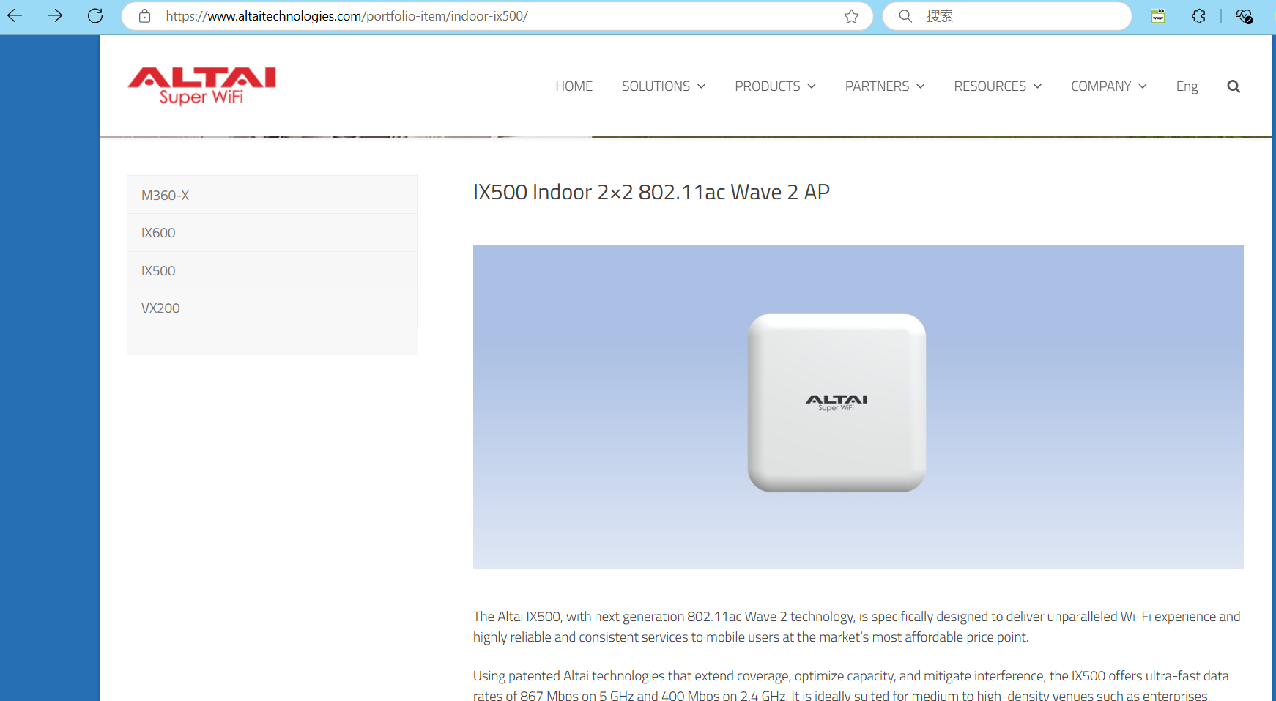

#### 2、Vulnerability description

IX500 Indoor 2×2 802.11ac Wave 2 AP After login, there are file reads in the background, and attackers can obtain sensitive information such as user credentials, system configuration, and database connection strings, which can lead to data breaches and identity theft.

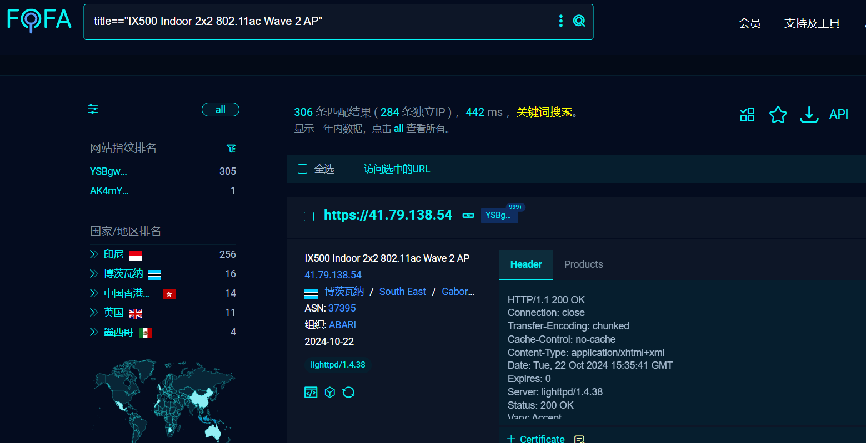

#### 3、Vulnerability recurrence process

1、After logging into the site administration interface, select:tools->Diagnosis->ping

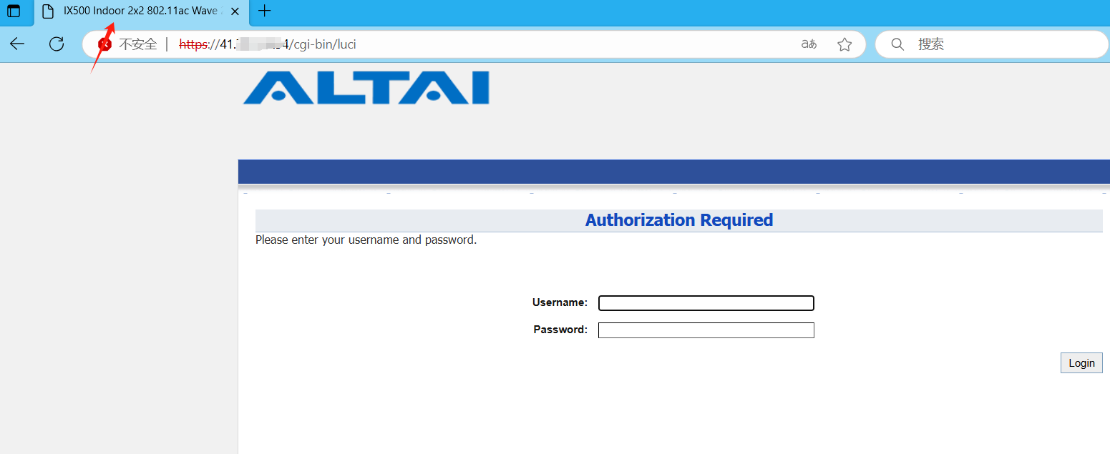

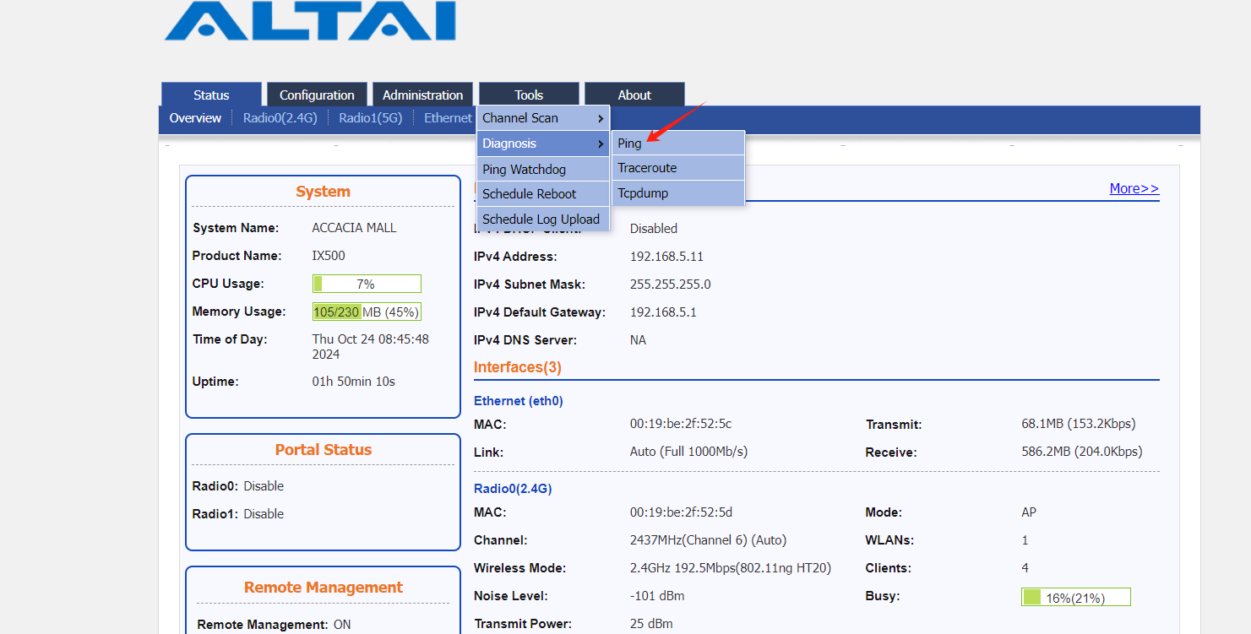

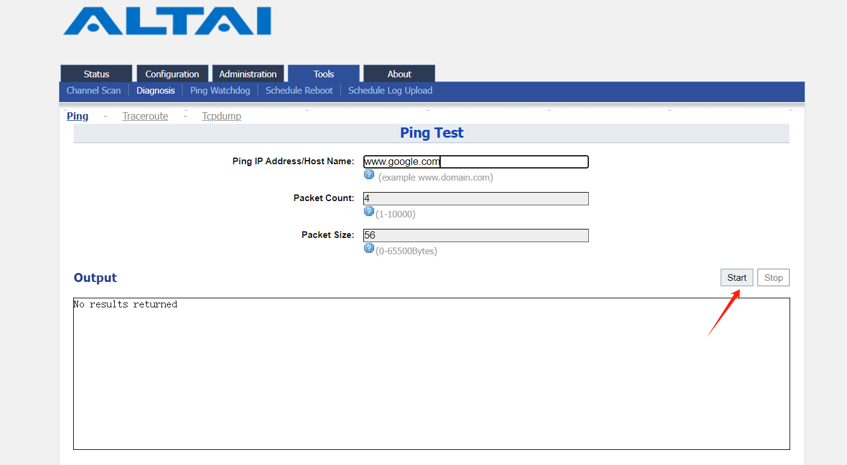

2、Enter any domain name or IP and click start to grab the packet

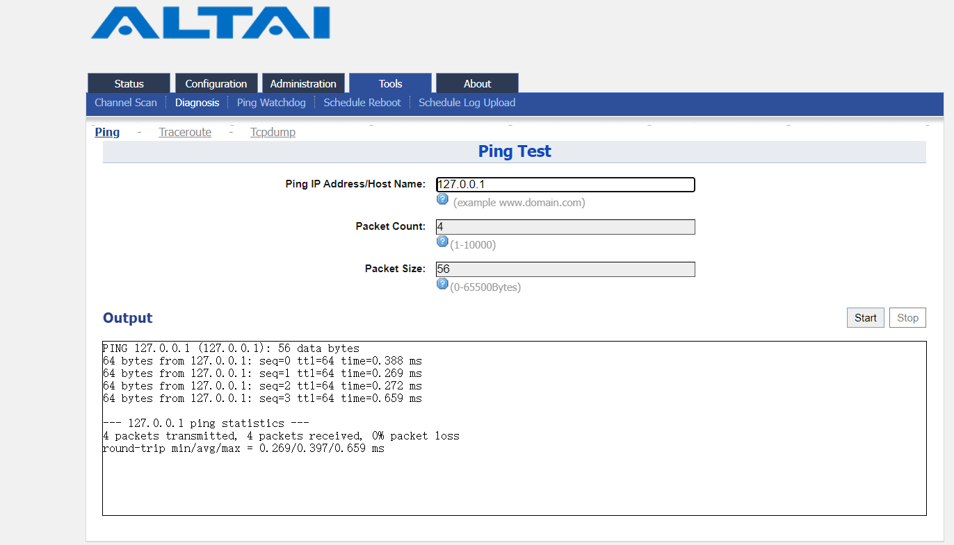

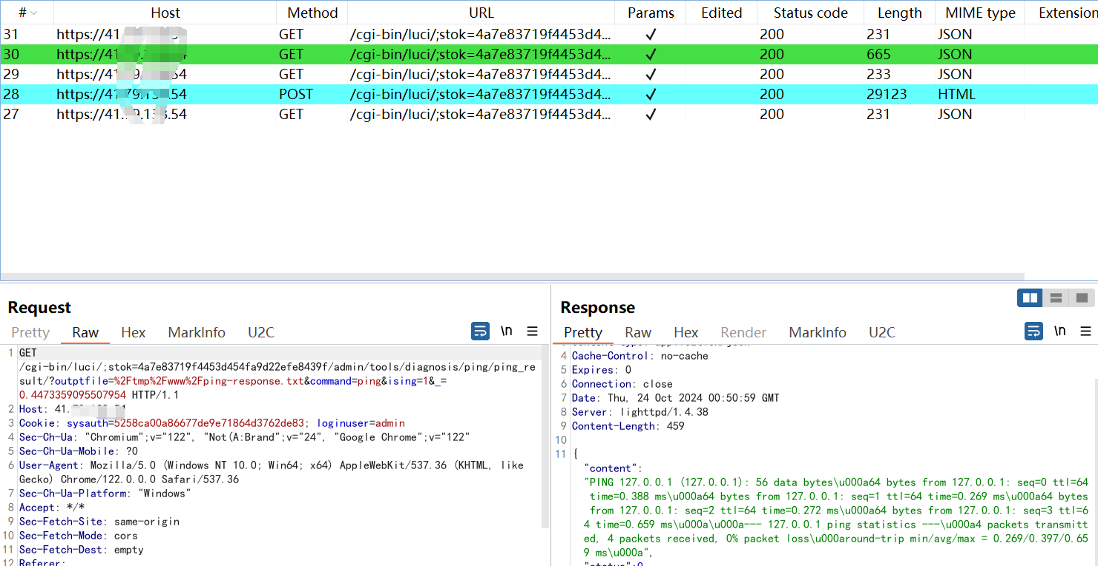

3、Change the request path of parameter outptfile to /etc/passwd, and the file information is read successfully:

